**ShopNest PowerBI Capstone Project**

ShopNest stands as the leading department store in the e-commerce marketplaces in Portugal. Serving as a seamless link, it connects small businesses from various regions in Portugal to channels, streamlining the process with a single point of contact. Through the ShopNest Store, these merchants can showcase and sell their products, with the added convenience of direct shipment to customers facilitated by ShopNest logistics partners.

**1. Identify the rating distribution in the Shop_Nest dataset, showcasing ratings categorized as Excellent, Very Good, Good, Bad, and Very Bad, along with corresponding orders.**

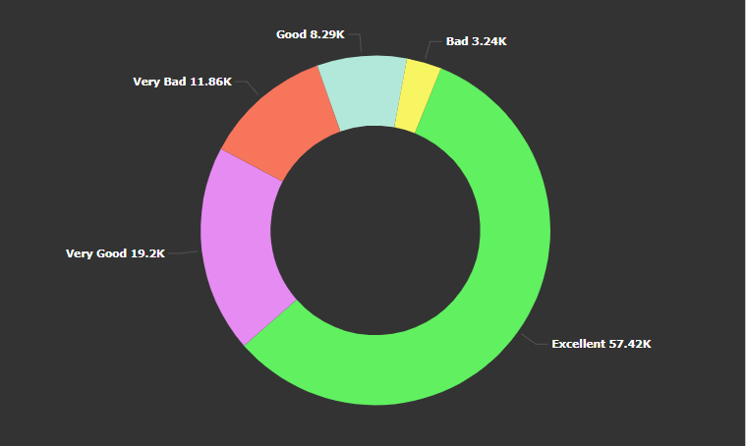

**INSIGHTS**

* The 57.42K customers given Excellent Rating to ShopNest.
* The 19.2K customers given Very Good Rating to ShopNest.

**2.What are the top 10 and bottom 18 most popular product categories in the ShopNest dataset? Please list them based on the number of orders.**

**Top 10 popular product**

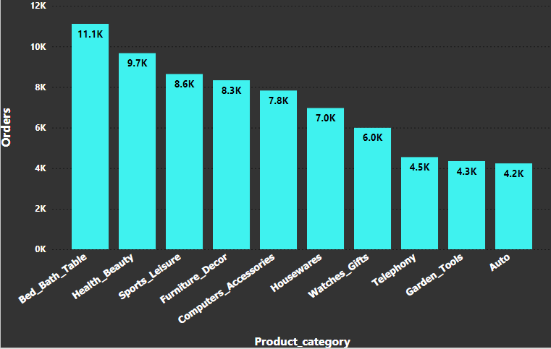

**Least 18 popular products**

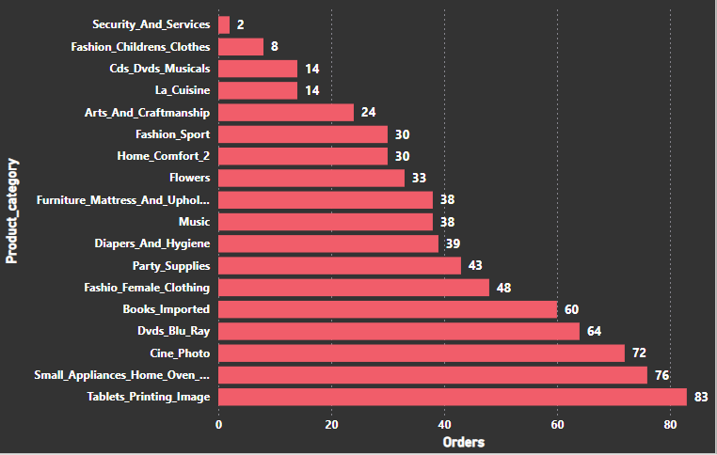

**INSIGHTS**

* The most popular products are Bed Baths Table, Sports Leisure and Furniture Décor.
* The least popular products are Security and Services, Fashion children clothing, CDs DVD Musicals and La Cuisine.

**3.List the total number of active sellers by yearly and monthly.**

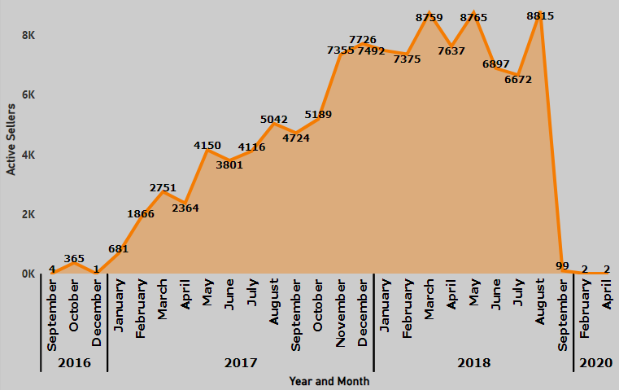

**INSIGHTS**

* In march 2018 and may 2018 there are high number of active sellers.
* In 2020 there is a drastic fall in active sellers in ShopNest.
* There is huge different between the active sellers from Jan 2017 to Dec 2017.

**4. Which payment methods are most commonly used by ShopNest customers.**

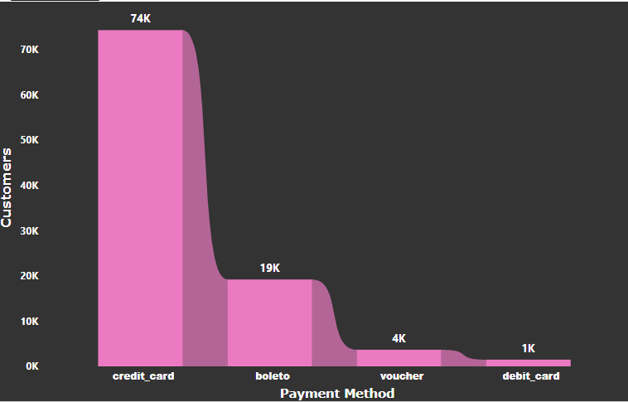

**INSIGHTS**

* Credit card has most commonly used payment method among the customers.
* Debit card is the rarely used payment method in ShopNest.

**5. Identify the product category wise profit margin.**

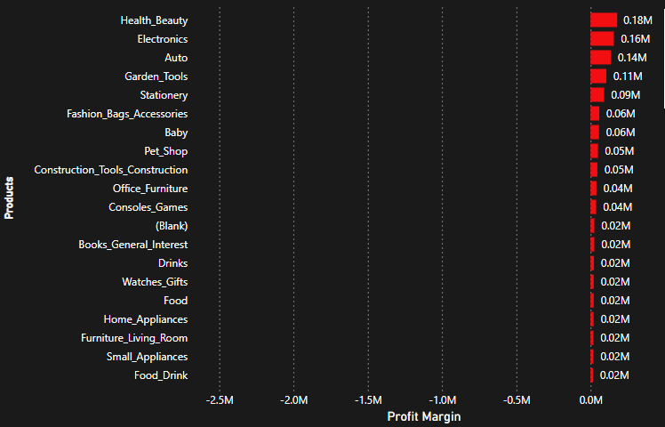

**INSIGHTS**

* According to the report Heath beauty, Electronic and Auto give the high profit margin.
* The Telephony, Bed bath table and furniture and made the huge loss for shopNest.

**6. Determine the monthly payments made by customers using credit cards.**

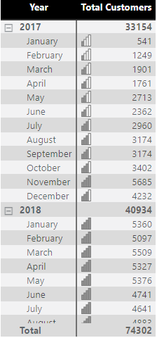

**INSIGHTS**

* The overall credit card using customers are 74302.
* The huge utilization of credit card has made in 2018 with 40934 payments.
* In November 2017 the highest of 5685 customers paid via credit card.
* In December 2016 only one customer used credit card for payment.

**7. Identify sellers categorized by city, excluding cities starting with the letters S and B.**

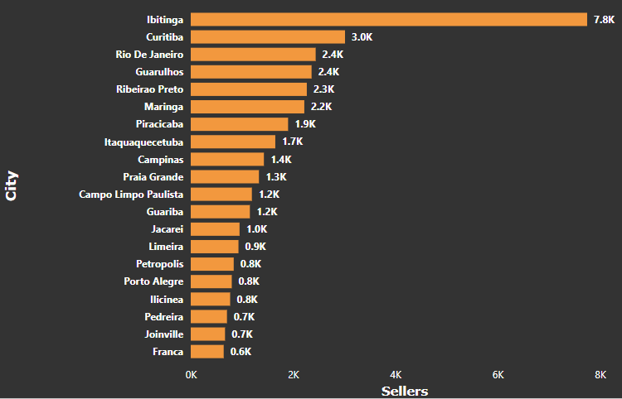

**INSIGHTS**

* According to the question the city has been filter, so the S and B starting city will be not considered.
* The maximum sellers in the Ibitinga city with 7.8K followed by Curitiba city with 3k and followed by Rio De Janeiro2.4k.
* The least sellers or no sellers in Viana and Uruguaiana.
* The Ibia city and Luanda city having least 40 sellers.

**8. Create a dynamic visual that compares the number of delayed orders to the number of orders received earlier for each month. Utilize the drill through the cross-report feature to provide a detailed analysis of la and on-time deliveries.**

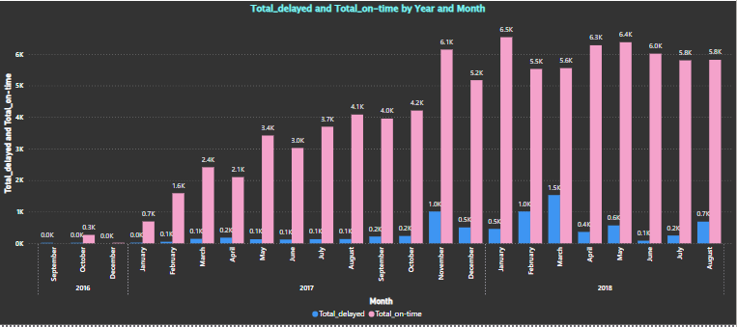

**INSIGHTS**

According to the report the products are delivered earlier to the customers.

Around 6.5k customer in Jan 2018 has received their products earlier.

The maximum delayed delivery recorded in the month of March 2018.

The maximum products delivered Earlier in 2018.